**Mudralekha: An Assamese Sign Language**

**Recognition system**

A project submitted in partial fulfillment of the requirement for the Degree of Bachelor of Technology in Power Electronics and Instrumentation Engineering

**Submitted by**

Bidisha Bhuyan (210810017009)

Chhaya Prasad (210810017010)

Madhusmita Bhuyan (210810017018)

Himangshu Chetia (220850017002)



**Submitted to**

**Department of Power Electronics and Instrumentation Engineering**

**JORHAT INSTITUTE OF SCIENCE & TECHNOLOGY, JORHAT-10**

**AFFILATED TO**

**ASSAM SCIENCE & TECHNOLOGY UNIVERSITY**

**MUDRALEKHA: An Assamese Sign Language Recognition system**

**[Code No: PI181722/04]**

A project submitted in partial fulfilment of the requirement for the Degree of Bachelor of Technology in Power Electronics and Instrumentation Engineering

Submitted by

Bidisha Bhuyan (210810017009)

Chhaya Prasad (210810017010)

Madhusmita Bhuyan (210810017018)

Himangshu Chetia (220850017002)

Under the supervision

Mrs Chandana Dev (Asst. Professor, Dept. PEI)

Jorhat Institute of Science and Technology, Jorhat-10

Submitted to

Department of Power Electronics and Instrumentation Engineering

Jorhat Institute of Science &Technology

Jorhat-10

**Certificate of Approval from Department of Power Electronics and Instrumentation Engineering, Jorhat Institute of Science & Technology**

The undersigned certify that the project report entitled “**Mudralekha – An Assamese Sign Language Recognition system**” have been read and recommended to the Department of Power Electronics and Instrumentation Engineering for acceptance, submitted by **Bidisha Bhuyan** in partial fulfilment for the Degree of Bachelor in Power Electronics and Instrumentation Engineering.

…………………………..

Mrs Chandana Dev

Supervisor

Assistant Professor, Dept. PEI

Jorhat Institute of Science and Technology

Jorhat- 10

……………………………..

Mrs Chandana Dev

Head of Department, PEI

Jorhat Institute of Science and Technology

Jorhat- 10

**Certificate of Approval from Department of Power Electronics and Instrumentation Engineering, Jorhat Institute of Science & Technology**

The undersigned certify that the project report entitled “**Mudralekha – An Assamese Sign Language Recognition system**” have been read and recommended to the Department of Power Electronics and Instrumentation Engineering for acceptance, submitted by **Chhaya Prasad** in partial fulfillment for the Degree of Bachelor in Power Electronics and Instrumentation Engineering.

…………………………..

Mrs Chandana Dev

Supervisor

Assistant Professor (PEI)

Jorhat Institute of Science and Technology

Jorhat- 10

……………………………..

Mrs Chandana Dev

Head of Department, PEI

Jorhat Institute of Science and Technology

Jorhat- 10

**Certificate of Approval from Department of Power Electronics and Instrumentation Engineering, Jorhat Institute of Science & Technology**

The undersigned certify that the project report entitled **“Mudralekha – An Assamese Sign Language Recognition system”** have been read and recommended to the Department of Power Electronics and Instrumentation Engineering for acceptance, submitted by **Madhusmita Bhuyan** in partial fulfillment for the Degree of Bachelor in Power Electronics and Instrumentation Engineering.

…………………………..

Mrs Chandana Dev

Supervisor

Assistant Professor (PEI)

Jorhat Institute of Science and Technology

Jorhat- 10

……………………………..

Mrs Chandana Dev

Head of Department, PEI

Jorhat Institute of Science and Technology

Jorhat- 10

**Certificate of Approval from Department of Power Electronics and Instrumentation Engineering, Jorhat Institute of Science & Technology**

The undersigned certify that the project report entitled **“Mudralekha – An Assamese Sign Language Recognition system”** have been read and recommended to the Department of Power Electronics and Instrumentation Engineering for acceptance, submitted by **Himangshu Chetia** in partial fulfillment for the Degree of Bachelor in Power Electronics and Instrumentation Engineering.

…………………………..

Mrs Chandana Dev

Supervisor

Assistant Professor (PEI)

Jorhat Institute of Science and Technology

Jorhat- 10

……………………………..

Mrs Chandana Dev

Head of Department, PEI

Jorhat Institute of Science and Technology

Jorhat- 10

**Certificate of Approval from**

**Committee on Final Examination for Evaluation of the Project Report**

The undersigned certify that the project report entitled **“Mudralekha – An Assamese Sign Language Recognition system”** have been read and recommended to the Department of Power Electronics and Instrumentation Engineering for acceptance, submitted by **Bidisha Bhuyan, Chhaya Prasad, Madhusmita Bhuyan** and **Himangshu Chetia** in partial fulfillment for the Degree of Bachelor in Power Electronics and Instrumentation Engineering.

……………………………..

(Name of the External Examiner)

External Examiner

Full designation:

Organization:

……………………………..

Mrs Chandana Dev

Supervisor

Assistant Professor (PEI)

Jorhat Institute of Science and Technology

Jorhat- 10

**ACKNOWLEDGMENT**

We would like to express our sincere gratitude to **Mrs. Chandana Dev,** **Assistant Professor**, Department of Power Electronics and Instrumentation Engineering, for her invaluable guidance, support, and supervision throughout this project. Her expertise, enthusiasm, and dedication have been instrumental in shaping the direction of our work and ensuring its successful completion. Her insightful inputs, constructive feedback, and constant encouragement have greatly enriched our learning experience.

We would also like to extend our thanks to our **Principal, Dr. Aditya Bihar Kandali**, for providing us with the necessary resources and facilities to carry out this project. We appreciate his continuous support and belief in our abilities.

We also extend our deepest gratitude to the teachers, staffs and supporters of **Jorhat Deaf and Dumb School** (Bodhir Vidyalaya), Atilagaon, for their dedication and commitment to providing the invaluable datasets crucial to our project work.

Bidisha Bhuyan (210810017009)

Chhaya Prasad (210810017010)

Madhusmita Bhuyan (210810017018)

Himangshu Chetia (220850017002)

**ABSTRACT**

Sign language, a visual-gestural mode of communication used by deaf and dumb serves as a rich and expressive medium for conveying linguistic and cultural messages. Numerous research has been performed to develop hand gesture-based applications for sign language recognition in various languages such as American, Turkish, Arabic, Indian and others. Though the major form of communication for the deaf community in India is Indian Sign Language, there are still scope for advancement of techniques and methods for the development of sign language within its various regional languages. Assamese is one such regional language, which is widely spoken in Assam, but still lacks substantial research in context to the sign language recognition. The primary cause of this research gap is the unavailability of benchmark dataset for the said sign language.

This project work aims for a noble approach to build a computer interface system for Assamese sign language (AaSL) recognition and text formation. To fulfil this objective a user-built dataset of ASL has been created, comprising **10 Assamese alphabets ( "অ", "আ", "ই", "ঈ", "উ", "এ", "ও", "ক", "জ", "ল").** A latest web-based tool called Mediapipe has been used in this context to create the dataset for static gestures of the mentioned alphabets. As a part of reference, standard form of Assamese sign language has been collected from Jorhat Bodhir Vidyalay (Deaf and Dumb School), Atilagaon. A deep neural network model has been designed to develop the overall recognition system. The proposed sign language recognition system has been successfully implemented with an accuracy of 100% for all the considered alphabets.

**LIST OF FIGURES**

|  |  |  |
| --- | --- | --- |
| **Figure No** | **Name of Figure** | **Page No** |
| 1 | Sign Language Recognition System | 2 |
| 2 | Literature Survey (2019-2024) | 6 |
| 3 | Workflow of the System | 7 |
| 4 | Mediapipe Hand Landmark | 8 |
| 5 | Sample Frame of Each Alphabet | 9 |
| 6 | Architecture of CNN Model | 10 |
| 7 | Model Comparison of CNN | 13 |
| 8 | Confusion Matrix | 16 |
| 9 | . a) Training and Validation Accuracy  b) Training and Validation loss | 17 |
| 10 | Real Time Recognition of Assamese Alphabets | 17-18 |
| 11 | Real Time Sign Language to Text Translation System | 19 |

**LIST OF TABLES**

|  |  |  |
| --- | --- | --- |
| **Table No** | **Table Name** | **Page No** |
|  | Overview of Dataset | 9 |
|  | Model Configuration | 12 |
|  | Hyper Parameter Setting | 12 |
|  | Classification Report | 15 |

**LIST OF ABBREVIATIONS**

|  |  |
| --- | --- |
| **ABBREVIATIONS** | **REPRESENTATIONS** |
| SLR | Sign Language Recognition |
| CNN | Convolutional Neural Network |
| ASL | American Sign Language |
| ISL | Indian Sign Language |
| AaSL | Assamese Sign Language |
| ROI | Region of Interest |

**CONTENT**

|  |  |  |
| --- | --- | --- |
| **SL.No.** | **Title** | **Page No.** |
| 1. | Introduction | 1-2 |
| 1.1 | Project Overview | 3 |
| 1.2 | System Requirements | 3 |
| 1.2.1 | Hardware | 3 |
| 1.2.2 | Software | 3 |
| 2. | Literature Review | 4 |
| 2.1 | American Sign Language (ASL) | 4 |
| 2.2 | Indian Sign Language (ISL) | 4-5 |
| 2.3 | Regional Sign Language | 5-6 |
| 3. | Methodology | 7 |
| 3.1 | Workflow of the System | 7 |
| 3.1.1 | Data Collection | 7-8 |
| 3.1.2 | Data Preprocessing | 8 |
| 3.1.3 | Hand Tracking | 8 |
| 3.1.4 | Proposed CNN Model | 10 |
| 3.1.5 | Feature Learning | 10-11 |
| 3.1.6 | Classification | 11 |
| 3.1.7 | Model Configuration & Hyper Parameter Setting | 11 |
| 3.1.8 | Challenges & Potential Solutions | 12 |
| 3.1.9 | System Implementation | 12 |
| 4. | Results | 13-19 |
| 5. | Conclusion and Future Scopes | 20 |
| 6. | References | 21-22 |

1. **INTRODUCTION:**

According to data from the June 2023 census, 63 million people in India, which accounts for roughly 6% of the country's total population, were reported to have auditory impairment. Additionally, over 1.5 million people worldwide had experienced hearing loss in the previous year. These individuals have developed their own form of communication known as sign language. These figures are based on research conducted by the World Health Organization (WHO) and other organizations. **[1]**.

Sign language is a visual-gestural communication system that many people with speech and hearing impairments use as their primary means of social interaction. It is a form of visual communication that follows a set of vocabulary and grammatical rules while communicating ideas through hand gestures and facial expressions **[2]**. Sign language can be divided into primary and secondary components, which can then be combined either simultaneously or sequentially. The primary components are the positions of the body and hands, the movements of the hands and fingers, and the hand shapes that are used to create a sign. Many signs include body language and facial expressions along with hand movements. The hand is particularly important in sign language as it can convey most gestures. A gesture is a hand motion in the spoken language that forms words, sentences, alphabets, and numerals. These motions can be dynamic, involving varying hand movements, or static, involving constant hand positions with no variation in the hands' or fingers' positions over time. **[3].**

Sign languages differ depending on where they are used. For example, American Sign Language is used in the United States, while Indian Sign Language is used in India. Indian Sign Language (ISL) is the primary means of communication for deaf people in India. ISL was recently officially recognized in 2016 under the Rights of Persons with Disabilities Act. As a result, the Indian Sign Language Research and Training Centre (ISLRTC) was established to promote and standardize ISL. There are 33 hand gestures in the ISL system, where 10 represent numbers and 23 represent letters **[4]**. Out of the more than 19,000 languages spoken in India, 22 are modern, and Assamese is one of them. It is widely spoken in the state with 15 million native speakers. The deaf and dumb community in Assam extensively uses Assamese Sign Language, using hand signals to represent each of the Assamese alphabets.

Sign language recognition (SLR) systems have recently been developed to help bridge the communication gap between the hearing and the deaf communities. In computer vision, the process of translating sign languages into spoken or written language is known as sign language recognition (SLR). Two main approaches are used when developing SLR systems: vision-based techniques that use images or videos, and glove-based techniques that use data gloves. Each method has its own equipment, cost, and accuracy requirements **[5]**. In recent years, researchers have conducted many experiments to create systems that can recognize sign language (SLR). Studies on various sign languages have been carried out globally, but there has been relatively little focus on specific Indian dialects like Assamese. **[6]**. A general representation of a SLR systems is depicted in Figure 1 below.

**Gesture Recognition and Conversion to Text**

**Human Computer Interface**

**Gesture Shown by User**

**Figure 1:** Sign Language Recognition System

Our research project aims to develop a new system for recognizing Assamese Sign Language. To achieve this, we will create a specialized dataset containing ten Assamese alphabets, known locally as Biyonjonborno (consonants) and Swaraborno (vowels), respectively. We have taken care to gather data on individual signs that can be combined to form meaningful two-letter Assamese phrases. Once the dataset is created, we will use machine learning techniques to identify and categorize these signs. Additionally, the system for recognizing Assamese sign language will be trained to recognize individual signs and combine them to form logical two-letter words.

* 1. **PROJECT OVERVIEW:**

### This project work aims to create a user-built dataset of 10 Assamese alphabet which comprises of 7 number of vowels (locally known as Swaraborno i.e. স্বরবর্ণ) and 3 consonants (locally known as Byonjonborno i.e. ব্যঞ্জনবর্ণ). The steps involved in the implementation of the overall project is outlined below:

* **Collection of Dataset*:***

1. Standard Dataset was collected from Jorhat Bodhir School (as mentioned in acknowledgment section) for reference.
2. A user-built dataset has been then developed comprising of total 800 images for each alphabet in jpg format.

* **Training and Testing:**

The built dataset is then further splitted into training and testing sets in the ratio 80:20, in order feed them to the deep neural network model.

* **CNN Architecture:**

CNN model is then developed with associated layers and hyperparameters settings (discussed in detail in Chapter 3) for the recognition of the sign language.

* **Real Time Recognition*:***

The system is trained and evaluated with the help of model performance metrics to predict the real time recognition of the alphabet and form text.

**1.2 SYSTEM REQUIREMENTS:**  Both software and hardware requirements for the presented project work is mentioned in the next two sections 1.2.1 & 1.2.2 respectively.

**1.2.1 HARDWARE*:***

The Hardware Interface specifications used:

**Camera:** Good quality, 4MP;**Ram:** Minimum 8GB or higher

**GPU:** 4GB dedicated Processor: Intel Core (i3) or higher HDD: 10GB or higher

**1.2.2 SOFTWARE:**

Software specifictaions used:

**Operating System:** Windows 11.

**Software Version**: Python 3.11; **IDE**: Pycharm

**Python Libraries:** OpenCV, Scikit, Media Pipe, TensorFlow, Keras, Numpy, matplotlib, Pillow.

1. **LITERATURE REVIEW:**

**2.1 AMERICAN SIGN LANGUAGE (ASL*)***

In the study by Sundar et al. (2022), the vision-based system effectively recognizes ASL alphabets and translates them into text using MediaPipe and LSTM models, achieving an accuracy of 99%. This system shows potential for human-computer interaction, allowing gestures to be translated into text for applications like typing or search engines, with possibilities for extension to real-time and multiletter recognition **[7]**.Chong et al. (2018) focused on 26 ASL letters and 10 digits, creating a sign language recognition system utilizing the Leap Motion Controller. Their study highlighted fingertip distance as a crucial feature, with the DNN classifier outperforming the SVM in terms of accuracy. Future research will investigate depth information, finger orientation, and extend the system to recognize words and sentences **[8]**. Thongtawee et al. (2018) proposed an innovative method for hand recognition by employing a 2D camera and relying on just four key parameters to derive features from hand images. Their system successfully classifies American Sign Language alphabet signs with impressive accuracy, though there are some minor errors added **[9]**. Wu et al. (2016) developed a wearable system for real-time American Sign Language (ASL) recognition by integrating IMU and sEMG sensors. By selecting optimal features and testing multiple classifiers, the system achieved 96.16% accuracy for 80 common ASL signs, highlighting the role of sEMG in improving recognition **[10]**. A. Hussain et al. (2024) developed a real-time recognition system for American Sign Language (ASL) that converts hand gestures of ASL fingerspelling into English text. The study utilized computer vision and deep learning techniques, focusing on convolutional neural networks (CNNs), to accurately recognize ASL signs in real time. The system developed by the authors achieved an impressive recognition accuracy of approximately 99.4%, suggesting that the proposed approach is highly effective for real-time ASL recognition **[11]**.

**2.2 INDIAN SIGN LANGUAGE (ISL)**

Rekbai et al. developed a method for recognizing Indian Sign Language by integrating shape, texture, and movement features of hand gestures, which significantly enhanced accuracy. Their approach proved effective in distinguishing similar signs, making it a valuable tool for sign language interpretation **[12]**. Sharma et al. (2022) developed a CNN-DSC model that reached accuracy rates of 92.43%, 88.01%, and 99.52% on three datasets. The model improved in robustness and performance through the use of data augmentation techniques, which helped it manage variations and scale changes effectively. In the work by Shenoy et al., the system achieves 99.7% accuracy in classifying 33 ISL hand poses and 97.23% accuracy for 12 gestures. Utilizing techniques like object stabilization and skin color extraction, alongside HMM and k-NN models, it delivers precise real-time recognition with processing times of 0.2s for hand poses and 0.0037s for gestures **[13]**. K. Shenoy et. al. (2021) Sahoo employed machine learning to recognize Indian Sign Language (ISL) by training their model with static hand gestures representing the digits 0 through 9. A digital RGB sensor was used to capture a dataset of 500 images, with one image representing each digit. They applied supervised learning methods, including Naive Bayes, achieving an average accuracy of 98.36%, with a slightly higher rate of 97.79% for some cases **[14]**. In Ansari et al.'s (2016) study, a Kinect sensor was used to achieve more than 90% accuracy for 13 signs and perfect recognition for three signs in the fingerspelling category for Indian Sign Language, and the system achieved an average accuracy of 90.68% across 16 distinct alphabets. The authors plan to release their dataset and code as open-source, aiming to fill the gap in available Kinect depth datasets for ISL and to support ongoing research in this area. **[15]**

**2.3 REGIONAL SIGN LANGUAGE**

Huda et al. (2019) introduce a two-way communication system between Bangla Sign Language (BdSL) and Bangla, aiming to improve on previous limitations. While the system emphasizes real-time BdSL recognition, the conversion from Bangla to BdSL requires extensive datasets and grammatical structures that are not yet fully established **[16]**. Sultana et al. (2018) developed a DCNN-based framework to recognize Bengali Sign Language (BSL) using a dataset of 1,147 images covering 37 one-handed signs. The system attained an accuracy of 96.33% on the training data and 84.68% on the test data, showing strong performance across different conditions **[17]**. Tasmere et al. (2021) developed a real time hand gesture recognition system that aimed at enhancing communicaton for individuals with hearing impairments. The model, built with multiple convolutional, pooling, and fully connected layers, achieved an accuracy of 97.63%. Additionally, they created a dataset of 1,674 Bangla sign digit images, aiming to overcome limitations in future studies and further enhance real-time sign language recognition **[18]**. Bora et al. introduced a real-time Assamese sign language recognition system using MediaPipe and deep learning. Their method, which uses a custom dataset and Feed Forward Neural Network, offers faster and more accurate classification of hand signs compared to traditional approaches. MediaPipe's hand tracking ensures precise gesture recognition and broad device compatibility, with future work planned to include more signs and dynamic gestures **[6]**.

**Figure 2-** Literature Survey (2019-2024)

1. **METHODOLOGY**

**3.1 WORKFLOW OF THE SYSTEM**

The proposed Assamese sign language system is implemented in 4 essential steps: Data preparation, model building and training, real time recognition of signs, threading of sign characters to form words. The overall workflow of the presented system is depicted in figure.

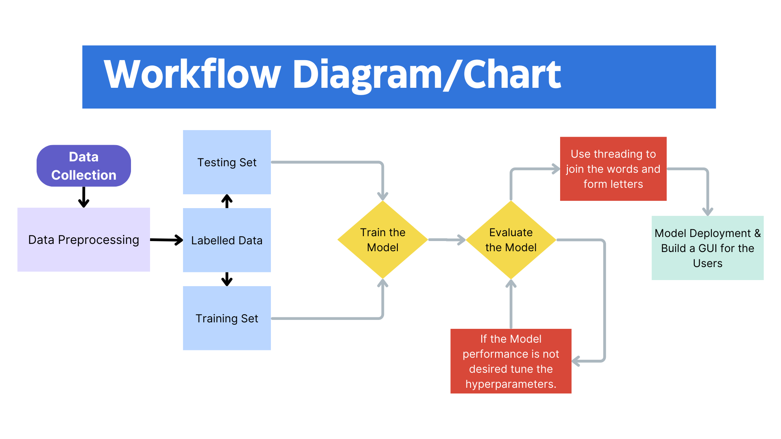

**Figure 3:** Workflow of the System

**3.1.1 DATA COLLECTION**

In the data collection process, a dataset of 10 gestures of the Assamese sign language was created which distinctly represented the Assamese alphabets. The 10 alphabets included **"অ", "আ", "ই", "ঈ", "উ", "ও", "এ", "ক", "জ", "ল".** These signs were originally developed by the Vaani® Foundations in 2021. The data for these signs was collected using OpenCV for capturing of frames and processing, along with MediaPipe for landmark detection to accurately analyse hand gestures and movements. MediaPipe is a Google’s open-source library that enables real-time tracking of hand movements and locations. With 21 landmarks collected for each hand by the hand tracker module, spatial arrangement and motion data were captured that are vital for subsequent phases of the sign language recognition model.

The entire process was carried out in the PyCharm environment to ensure efficient development and execution. With the required coding and enabling the webcam of the operating device the images were captured which contained static hand gestures that included 7 out of 11 vowels and 3 out of 41 consonants of ASL.

**3.1.2 DATA PREPROCESSING**

Once the data was collected, it is made into 10 classes and further labelling of the dataset is done. It has labels as: **"অ", "আ", "ই", "ঈ", "উ", "ও", "এ", "ক", "জ", "ল".**

Each class contains 800 images i.e. 800 images of each character were captured in jpg format. This is then further splitted into the training and the testing set in 80:20 ratio.

**3.1.3 HAND TRACKING**

Google Open source MediaPipe module have been utilized for ensuring precise hand gesture recognition in the proposed sign language recognition architecture. This module enables real time tracking of motions and locations of the hands. With 21 landmarks collected from each hand by the hand tracking module. Figure 1. Shows the hand landmarks output from the MediaPipe Hand tracking module.

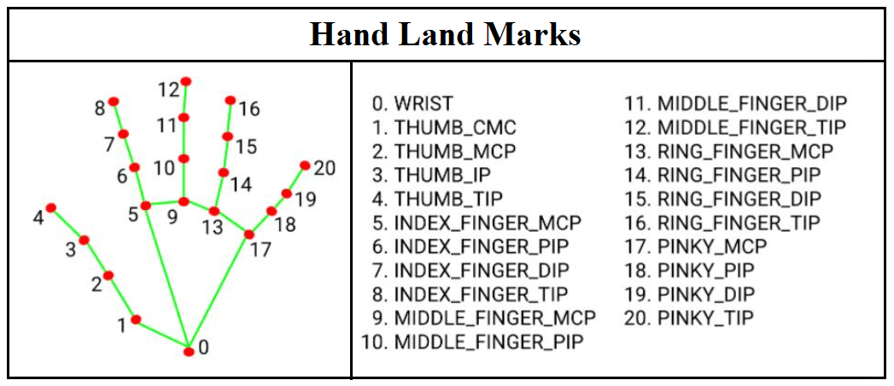

**Figure 4:** MediaPipe Hand Landmark

|  |  |  |  |
| --- | --- | --- | --- |
| **Class** | **Total Dataset Per Class** | **Training Dataset** | **Testing Dataset** |
| **অ** | 800 | 640 | 160 |
| **আ** | 800 | 640 | 160 |
| **ই** | 800 | 640 | 160 |
| **ঈ** | 800 | 640 | 160 |
| **উ** | 800 | 640 | 160 |
| **ও** | 800 | 640 | 160 |
| **এ** | 800 | 640 | 160 |
| **ক** | 800 | 640 | 160 |
| **জ** | 800 | 640 | 160 |
| **ল** | 800 | 640 | 160 |
| **TOTAL** | 8000 | 6400 | 1600 |

**Table 1:** Overview of Dataset

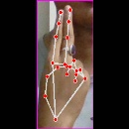 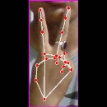 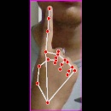 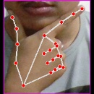 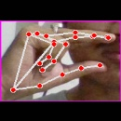

অ আ ই ঈ উ

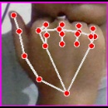 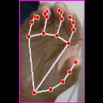 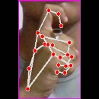 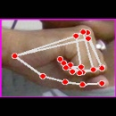 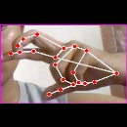

এ ও ক জ ল

**Figure 5:** Sample frame of each alphabet

**3.1.4** **PROPOSED CNN MODEL**

A Convolution neural network is a type of deep learning algorithm that is particularly well suited for image recognition and processing tasks. The convolution neural network is made up of multiple layers, including convolution layers, max pooling layers and fully connected dense layers.

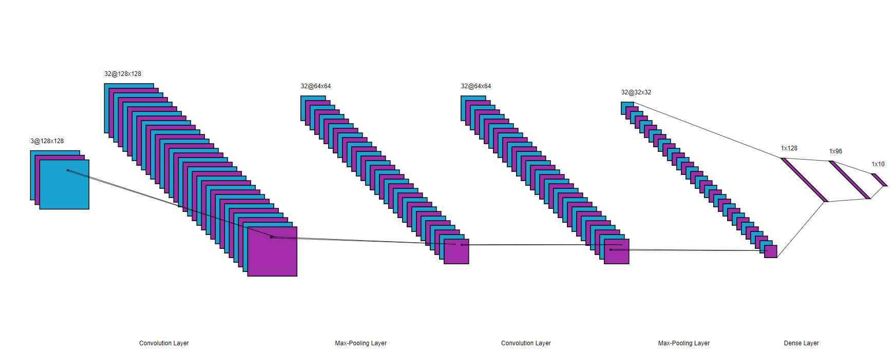

**Figure 6: Architecture of CNN Model**

**3.1.5 FEATURE LEARNING**

The feature learning is a process which involves learning and extracting important features from the input data, such as images. CNNs model are basically composed of multiple layers that plays an important role in feature extraction. This approach entails a CNN architecture comprising an input layer, followed by two Convolution layers each accomplished by max-pooling layers, all contributing to this approach. The input layer receives the raw images typically represents as matrices of pixel values. The convolution layer extract features from the filters (kernels), which identifies the patterns such as edges, textures, or shape through convolution operations. In this process 32 filters with kernel size 3x3 is applied. Furthermore, the convolution layers use ‘ReLU’ as activation function. Activation function purpose is to introduce non-linearity into the model, allowing the network to learn and represent complex patterns in the data. Padding is involved in this approach as it helps in reducing the loss of information at the borders of the input feature map and can improve the performance of the model. Overall, padding is an important technique in CNNs as it helps in preserving the spatial dimensions of the feature maps. In this approach a 2x2 size pooling layers is used. Pooling layers reduces the dimensions of the feature maps, the number of parameters to learn and the amount of computation performed in the model. The Max-Pooling operation selects the maximum elements from the region of the feature map covered by the filter. The output is a feature map containing the important features of the previous feature map.

**3.1.6 CLASSIFICATION**

The output layers of the CNN or the fully connected layers is used for classification of letters. The fully connected layers receive flatten features from the earlier layer and convert them into vector form ideally for classification purpose. In this approach, the softmax function is used to produce the probability of each class. The model uses Adam optimizer which adjusted the weights and biases of the fully connected layer during training to minimize the loss function. The loss function is selected as Categorical Crossentropy, which provides a loss between actual and expected class. The output of the fully connected layers represents the prediction or classification of the classes.

**3.1.7 MODEL CONFIGURATION AND HYPER PARAMETERS SETTINGS**

In this approach we design a 2D CNN model. Numerous experiments were done with various hyper parameters settings to optimize performance of the model and minimize the loss as possible. In the Table.2 it shows the model summary or configuration while the Table.3 shows the different hyper parameter setting used in building of the model. Some of the parameters are kept on the standard values such as learning rate at 0.001 for Adam optimizer respectively. Additionally, each fully connected layers contain 128, 96 and 10 neurons and training process lasted for 10 epochs.

|  |  |
| --- | --- |
| **Layer** | **Output Shape** |
| Conv 2D | (None, 128, 128, 32) |
| Maxpooling 2D | (None, 64, 64, 32) |
| Conv 2D | (None, 64, 64, 32) |
| Maxpooling 2D | (None, 32, 32, 32) |
| Flatten | (None, 32768) |
| Dense | (None, 128) |
| Dense | (None, 96) |
| Dense | (None, 10) |

|  |  |
| --- | --- |
| Epochs | 10 |
| Batch Size | 128 |
| Learning Rate | 0.001 |
| Activation Function | ReLu |
| Optimizer | Adam |
| Loss Function | Categorial Cross Entropy |
| Padding | Same |

**Table 2:** Model Configuration **Table 3:** Hyperparameter Setting

**3.1.8 CHALLENGES AND POTENTIAL SOLUTIONS**

The system encountered limitations when displaying non-ASCII labels such as (**"অ", "আ", "ই", "ঈ", "উ", "ও", "এ", "ক", "জ", "ল".**) due to lack of support for non- ASCII characters in OpenCV. OpenCV only supports three types of fonts Hershey Font, True Font, and Custom Font.

To resolve this issue, this approach utilizes the “Noto Sans Bengali Font” from google as it’s compatible with OpenCV and supports Unicode, ensuring accurate rendering of Bengali characters.

**3.1.9 SYSTEM IMPLEMENTATION**

1. To operationalize the Sign Language Recognition (SLR) system an algorithm is designed that extracts the ROI (Region of Interest) of the real-time hand motions to recognize the Assamese alphabets.

2. The alphabet's display above the ROI (Region of Interest) as expected Assamese text label. It makes the SLRs efficient to accurately identify and interpret the gestures in real-time.

1. **RESULTS**

The below graph illustrates a comparison of five CNN models based on their accuracy and loss. Among the models, the fifth model demonstrates exceptional performance, achieving a perfect accuracy of 100% and a loss of 0%, making it the most effective and reliable option. The progression of accuracy and reduction in loss across the models indicate continuous optimization and refinement of the network architecture and parameters. Starting from Model 1 with 64% accuracy and 36% loss, subsequent models show significant improvements, culminating in Model 5. This comparison highlights the superior capability of the fifth model in achieving the highest accuracy while minimizing error, establishing it as the optimal choice for deployment.

**Figure 7:** Model Comparison of CNN

In this section, the result of the proposed system is displayed through tables and figures. The performance of the proposed system is assessed based on performance evaluation metrics. Accuracy, precision, recall and F1 score are commonly used metrics to evaluate the performance of classification models. Below is a description of every measure.

The **accuracy matrix** measures the accuracy of model from the complete dataset in terms of correctly predicted labels. The mathematical formula for the accuracy matrix is shown in Equation (1).

The **precision matrix** measures how accurate the model is from the predicted positives. The number of actual positives is calculated from the predicted positives and is a great measure to see when the false positive cost (FP) is high.

The **recall matrix** measures the number of predictions the proposed model correctly labels as positives. This is a measure to see how many predictions are associated with false positives (FN). The mathematical formulation for the recall matrix is given in equation (3).

The **F1 score** is a cumulative measure that combines recall and precision. The mathematical formula is given in Equation (4).

$A\left(Accuracy\right)=\frac{TP+TN}{TP+TN+FP+FN}$ (1)

$P\left(Precision\right)=\frac{TP}{TP+FP}$ (2)

$R\left(Recall\right)= \frac{TP}{TP+F}$ (3)

$F1Score=\frac{2*P*R}{P+R}$ (4)

Where; TP = True Positive, TN = True Negative, FP= False Positive, FN =False Negative

The comprehensive classification report, which outlines the CNN model’s performance metrics like Precision, recall and F-measure, is provided in Table 4. For quantitative analysis of the test dataset, confusion matrix library from python’s scikit-learn toolkit was also used.

**Table4:** Classification Report

|  |  |  |  |
| --- | --- | --- | --- |
| **Classes** | **Precision** | **Recall** | **F1-Score** |
| অ | 1.00 | 0.99 | 1.00 |
| আ | 0.99 | 0.99 | 1.00 |
| ই | 0.99 | 0.99 | 1.00 |
| ঈ | 1.00 | 1.00 | 1.00 |
| উ | 0.99 | 0.98 | 1.00 |
| এ | 1.00 | 0.98 | 1.00 |
| ও | 0.99 | 0.98 | 1.00 |
| ক | 1.00 | 1.00 | 1.00 |
| জ | 1.00 | 0.99 | 1.00 |
| ল | 1.00 | 0.99 | 1.00 |
| ACCURACY |  |  | 1.00 |
| MACRO AVG | 1.00 | 1.00 | 1.00 |
| WEIGHTED AVG | 1.00 | 1.00 | 1.00 |

The confusion matrix library evaluates the performance of our proposed model. It displays the counts of true positive (TP), true negative (TN), false positive (FP), and false negative (FN) predictions made by the model.

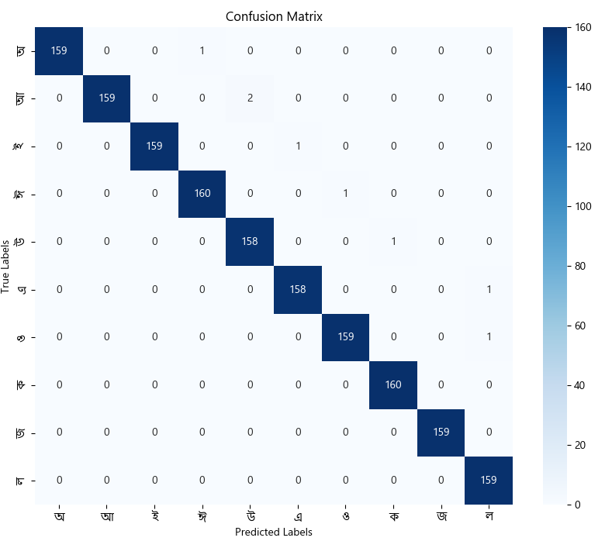The confusion matrix of the results of the suggested model is displayed here:

**Figure 8:** Confusion Matrix

After performing several experiments with different parameters, it has been observed that the proposed CNN model with the parameters as mentioned in Table 3, gave us an accuracy of 100%. The average validation accuracy of proposed CNN model and loss score are displayed in Figure 4. The number of training iterations is shown on the X-axis while the percentage of accuracy and loss score are shown on the Y-axis in Fig 4(a) and Fig 4(b), respectively. The average learning curve in Fig 4. (a), shows a steady improvement in the accuracy percentage with an increase in training, indicating that models are learning efficiently from data. The loss score is the total number of errors that the model predicted. Fig. 4(b) demonstrates that the mistakes immediately dropped immediately dropped as the number of training steps increased.

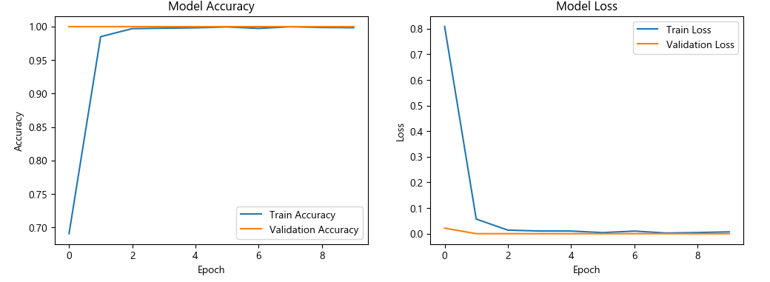**Figure9: a)** Training and Validation Accuracy **b)** Training and Validation Loss

Figure 10 showcases snapshots of the real-time recognition process. The result illustrates that the developed system successfully and accurately identifies gestures from Assamese sign language and convert them into text efficiently.

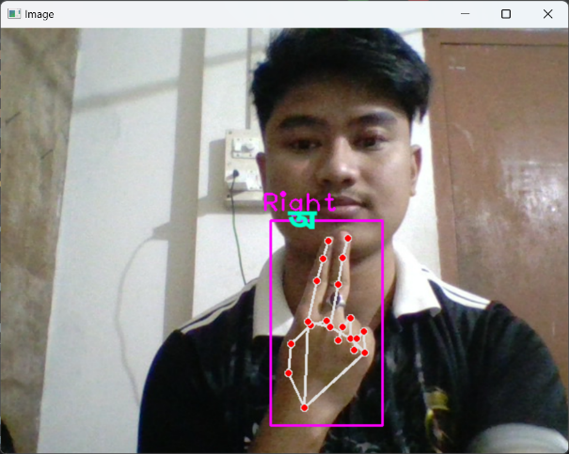 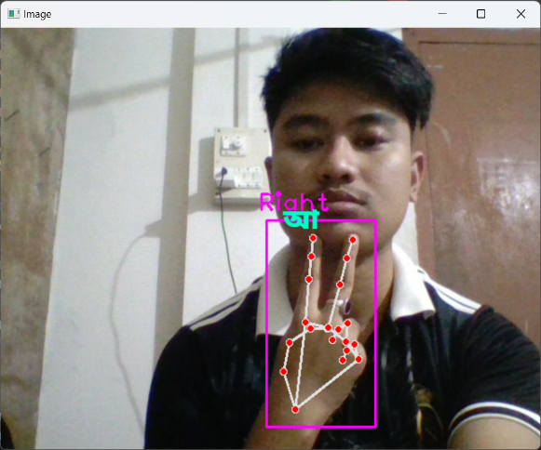

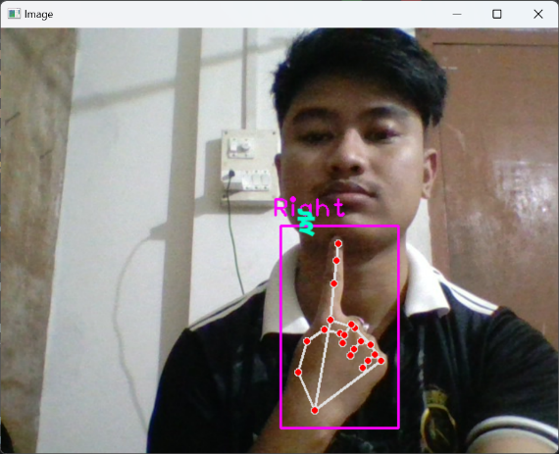 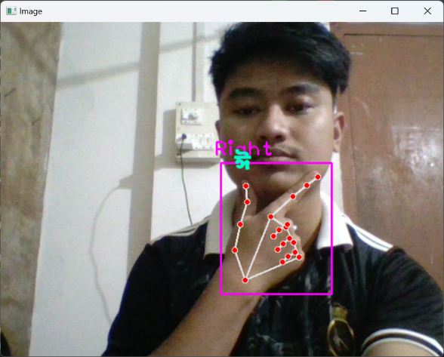

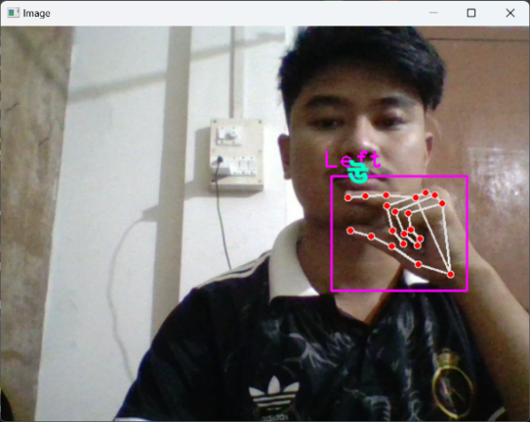 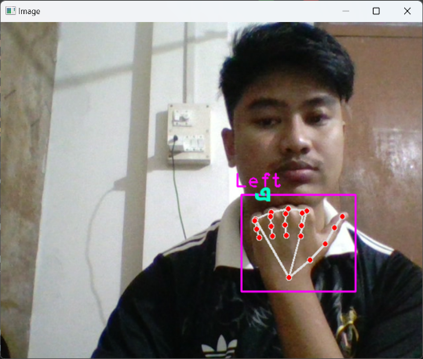

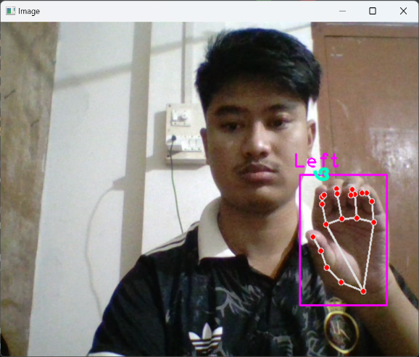 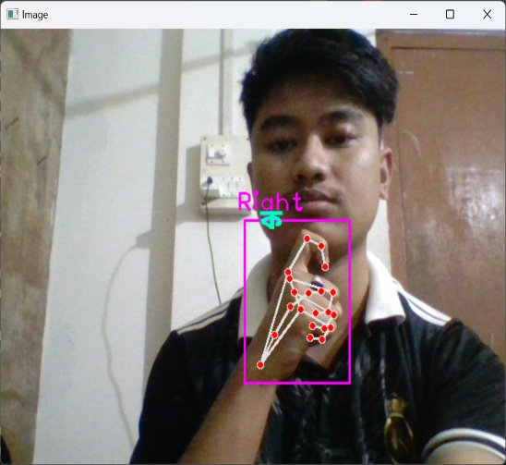

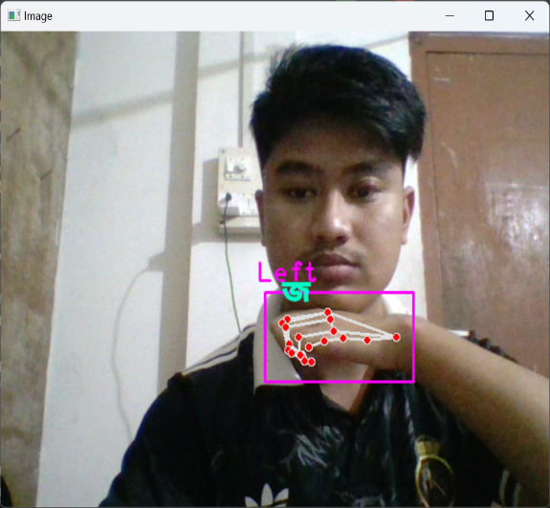 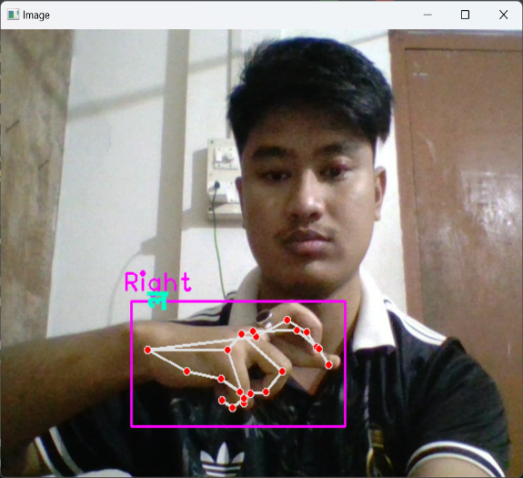

**Figure 10:** Real Time Recognition of Assamese alphabets

The system depicted in the image is a real-time Assamese Sign Language (AaSL) to Text Converter designed to bridge communication gaps for the deaf and hard-of-hearing community. Here's a detailed description:

**Features:**

1. **Real-Time Gesture Recognition**:
   * The left panel processes a live video feed to detect hand gestures using a pose detection model (likely leveraging Mediapipe or a similar library).
   * Key landmarks of the hand are highlighted with red dots, enclosed in a bounding box, and labelled with the hand type (e.g., "Right").
   * This provides real-time feedback to users, showing accurate tracking of hand

movements.

1. **Text Display**:
   * The right panel translates recognized gestures into Bengali characters and forms meaningful words and sentences.
   * The output is displayed in a large, readable format, aiding smooth communication.
2. **Interactive GUI Controls**:
   * Delete Last: Removes the most recently added character or word, allowing users to correct errors in the generated text.
   * Space: Adds a space, facilitating sentence formation.
   * Clear: Clears the entire text output to start fresh.

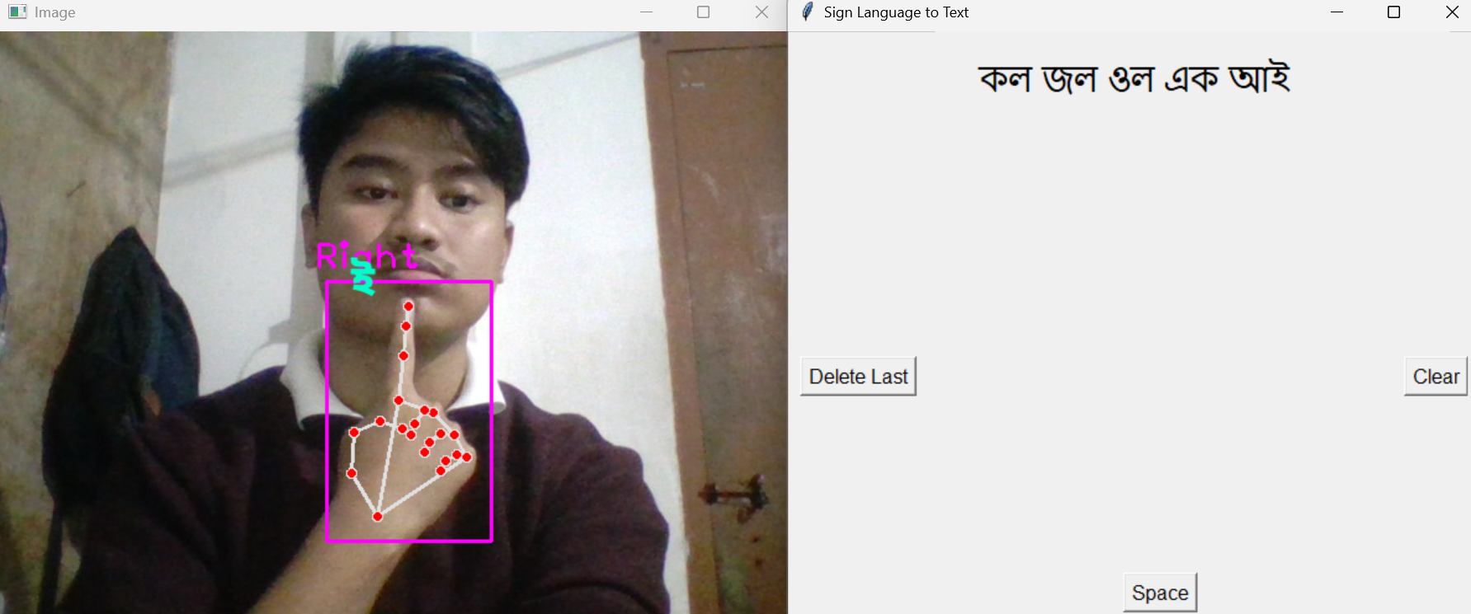

**Figure 11:** Real Time Sign Language to Text Translation System

**5.1 CONCLUSION**

In this research, we developed a comprehensive system for recognizing Assamese Sign Language (ASL) using advanced machine learning techniques, specifically Convolutional Neural Networks (CNN). Our goal was to bridge the communication gap between the deaf and hearing communities in Assam, focusing on a dataset of ten distinct Assamese alphabets.

The journey began with meticulous data preparation, which involved collecting and preprocessing static hand gesture images. We designed and trained a CNN model specifically for recognizing ASL signs. Our results showed that CNNs could effectively learn the unique features of ASL gestures, achieving impressive accuracy rates. By leveraging tools like OpenCV and MediaPipe, we were able to capture precise hand movements, ensuring our dataset was both reliable and rich.

The potential impact of our model is significant. It could facilitate real-time recognition of signs, enabling smoother communication and even the formation of two-letter words. This advancement would greatly enhance interactions for users, making everyday conversations more accessible.

However, while our results are promising, we recognize that there is still much work to be done. Future research could expand our dataset to include more signs and dynamic gestures, which would make the system even more robust. Additionally, exploring integration with real-time video processing and mobile applications could further support practical ASL recognition in daily life.

Ultimately, our research is about more than just technology; it’s about empowering the Assamese deaf community by providing tools for better communication. This initiative aligns with broader efforts to promote inclusivity and accessibility for individuals with hearing impairments, fostering a more connected and understanding society.

**5.2 FUTURE SCOPE**

This study could be enhanced by including more dynamic signs from Assamese Sign Language. Additionally, the application could be updated to generate sentences using dynamic Assamese alphabets, making it easier to teach the language to the hard-of-hearing community. There's also the potential to share the developed dataset publicly to support future research in this area.

**6. REFERENCES**

[1] R. R. Verma, A. Konkimalla, A. Thakar, K. Sikka, A. C. Singh, and T. Khanna, “Prevalence of hearing loss in India,” *NMJI*, vol. 34, pp. 216–222, Jan. 2022, <https://doi.org/10.25259/NMJI_66_21>.

[2] V. Sharma, A. K. Gupta, A. Sharma, and S. Saini, “A unified approach for continuous sign language recognition and translation,” *Int J Data Sci Anal*, Apr. 2024, <https://doi.org/10.1007/s41060-024-00549-2>

[3] S. Sharma and S. Singh, “A Spatio-Temporal Framework for Dynamic Indian Sign Language Recognition,” *Wireless Pers Commun*, vol. 132, no. 4, pp. 2527–2541, Oct. 2023, <https://doi.org/10.1007/s11277-023-10730-8>

[4] A. Hussain, N. Saikia, and C. Dev, “Advancements in Indian Sign Language Recognition Systems: Enhancing Communication and Accessibility for the Deaf and Hearing Impaired,” *AJES*, vol. 12, no. 2, pp. 37–49, Dec. 2023, <https://doi.org/10.51983/ajes-2023.12.2.413>.

[5] A. K. Sahoo, “Indian Sign Language Recognition Using Machine Learning Techniques,” *Macromolecular Symposia*, vol. 397, no. 1, p. 2000241, Jun. 2021, <https://doi.org/10.1002/masy.202000241>.

[6] J. Bora, S. Dehingia, A. Boruah, A. A. Chetia, and D. Gogoi, “Real-time Assamese Sign Language Recognition using MediaPipe and Deep Learning,” *Procedia Computer Science*, vol. 218, pp. 1384–1393, 2023, <https://doi.org/10.1016/j.procs.2023.01.117>.

[7] B. Sundar and T. Bagyammal, “American Sign Language Recognition for Alphabets Using MediaPipe and LSTM,” *Procedia Computer Science*, vol. 215, pp. 642–651, 2022, <https://doi.org/10.1016/j.procs.2022.12.066>

[8] T.-W. Chong and B.-G. Lee, “American Sign Language Recognition Using Leap Motion Controller with Machine Learning Approach,” *Sensors*, vol. 18, no. 10, p. 3554, Oct. 2018, <https://doi.org/10.3390/s18103554>

[9] A. Thongtawee, O. Pinsanoh, and Y. Kitjaidure, “A Novel Feature Extraction for American Sign Language Recognition Using Webcam,” in *2018 11th Biomedical Engineering International Conference (BMEiCON)*, Chiang Mai: IEEE, Nov. 2018, pp. 1–5. <https://doi.org/10.1109/BMEiCON.2018.8609933>.

[10] J. Wu, L. Sun, and R. Jafari, “A wearable system for recognizing american sign language in real-time using imu and surface emg sensors,” *IEEE J. Biomed. Health Inform.*, vol. 20, no. 5, pp. 1281–1290, Sep. 2016, <https://doi.org/10.1109/JBHI.2016.2598302>.

[11] A. Hussain, N. Saikia, and C. Dev, "A Deep Learning Based Human Computer Interface for Sign Language Recognition," *Int. J. Eng. Res. Electr. Electron. Eng.*, vol. 11, no. 3, pp. 29, Mar. 2024.

[12] J. Rekha, J. Bhattacharya, and S. Majumder, "Shape, texture and local movement hand gesture features for Indian Sign Language recognition," *in Proc. Int. Conf. on Signal Processing and Communications (SPCOM)*, Bangalore, India, 2013, pp. 1-5.

[13] S. Sharma and S. Singh, “Recognition of Indian Sign Language (ISL) Using Deep Learning Model,” *Wireless Pers Commun*, vol. 123, no. 1, pp. 671–692, Mar. 2022, <https://doi.org/10.1007/s11277-021-09152-1>

[14] K. Shenoy, T. Dastane, V. Rao, and D. Vyavaharkar, “Real-time Indian Sign Language (ISL) Recognition,” 2021, <https://doi.org/10.48550/ARXIV.2108.10970>.

[15] Z. A. Ansari and G. Harit, “Nearest neighbour classification of Indian sign language gestures using kinect camera,” *Sadhana*, vol. 41, no. 2, pp. 161–182, Feb. 2016, <https://doi.org/10.1007/s12046-015-0405-3>

[16] Professor Dr. M N Huda, I. Alam, S A. Siddique (5-6 December, 2019). Automated Bangla Sign Language Conversion System: Present and Future. Presented at Proceedings of the Language Technologies for All (LT4All), pages 61–65 Paris, UNESCO Headquarters

[17] M. A. Hossen, A. Govindaiah, S. Sultana, and A. Bhuiyan, “Bengali Sign Language Recognition Using Deep Convolutional Neural Network,” in *2018 Joint 7th International Conference on Informatics, Electronics & Vision (ICIEV) and 2018 2nd International Conference on Imaging, Vision & Pattern Recognition (icIVPR)*, Kitakyushu, Japan: IEEE, Jun. 2018, pp. 369–373, <https://doi.org/10.1109/ICIEV.2018.8640962>.

[18] D. Tasmere, B. Ahmed, and S. R. Das, “Real Time Hand Gesture Recognition in Depth Image using CNN,” *IJCA*, vol. 174, no. 16, pp. 28–32, Jan. 2021, <https://doi.org/10.5120/ijca2021921040>.